DAY9 Q3
BALAJI V
727723EUCS028
CSE-A
EC2 INSTANCE
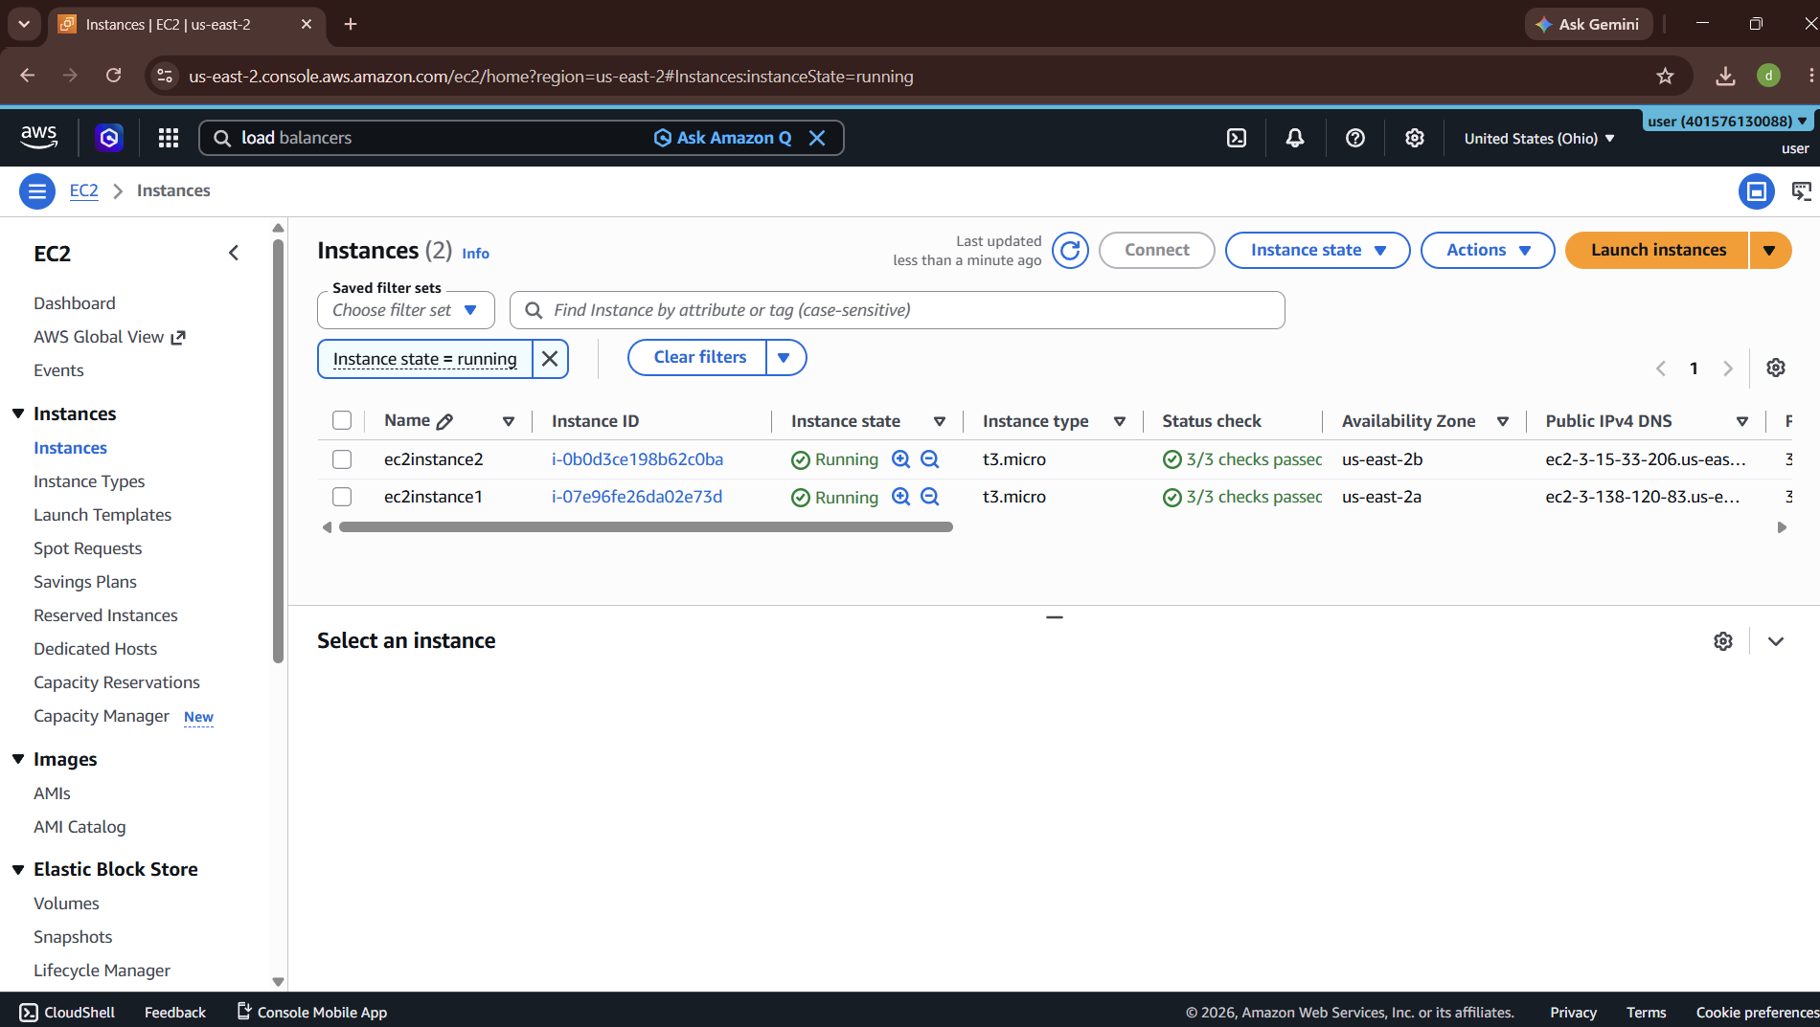
TARGET GROUP
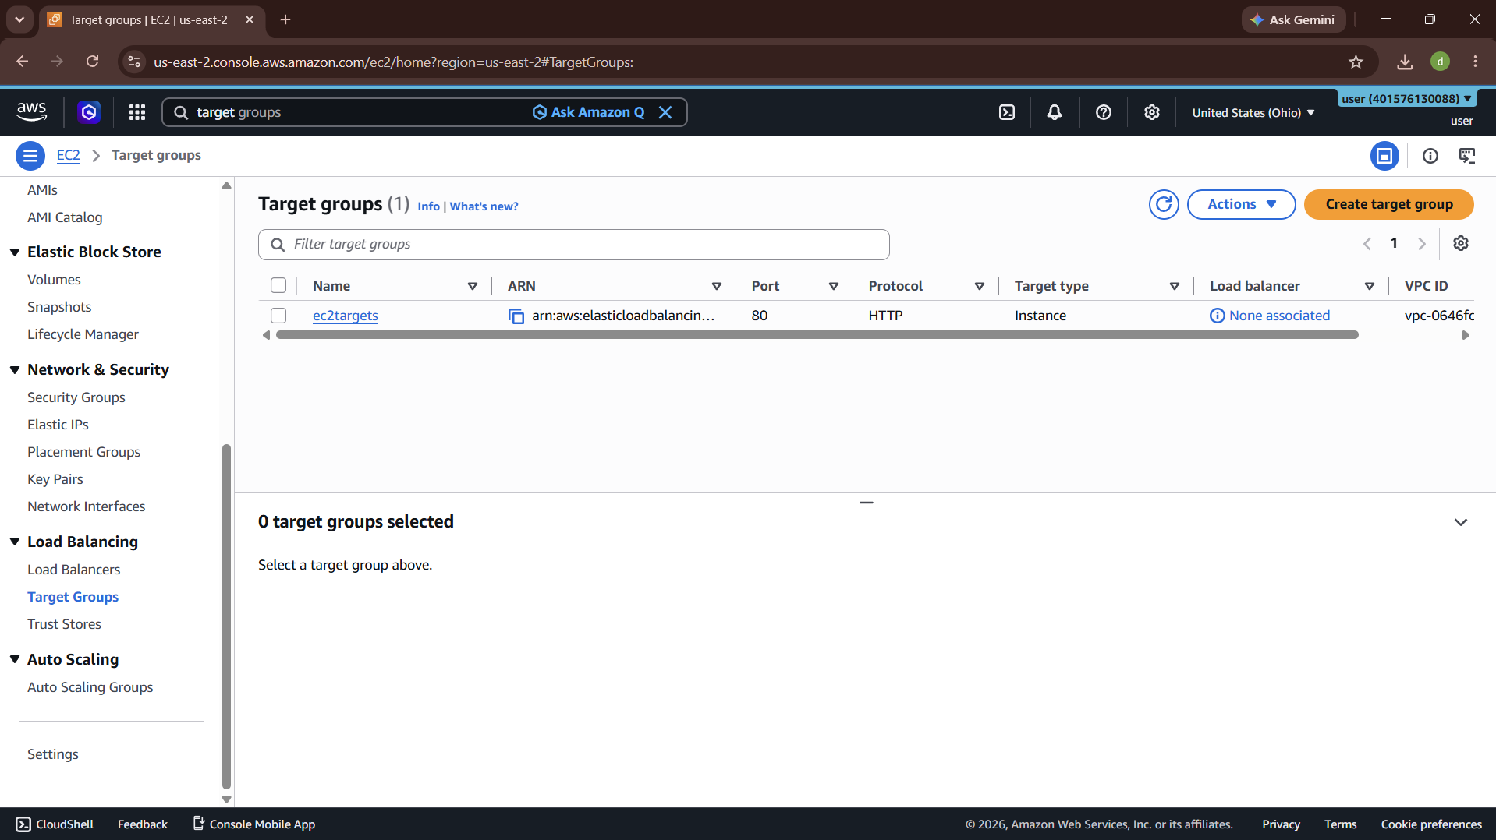
LOAD BALANCERS
